Mining needs to change to be sustainable
26 Oct 2018
South Africa needs to reshape its mining industry to fit a vision of a sustainable society. "This requires us to collectively engage in changing the current economic model in this country," said Bishop Jo Seoka, chairperson of the Bench Marks Foundation.
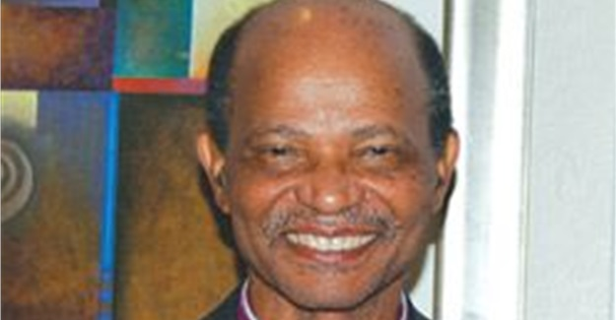
Bishop Jo Seoka
He added that a major mindset shift was needed by government and business to recognise the humanity, dignity and needs of communities, to acknowledge the right of mining impacted communities to experience the new dawn vision, and to recognise the simple and basic right to be related to and treated with dignity as human beings.

One of the richest countries on the planet
“We already know that on paper South Africa is one of the richest countries on the planet. Yet this ‘wealth’ based mainly on the extractive industries, cheap labour and high unemployment has not benefitted the vast majority of South Africans and has resulted in an ecological overshoot which has led to the degradation of our environment and poses a real threat to our food and water sovereignty. But most of all we concerned about people, communities who bear the brunt of mining, losing their livelihoods, access to water and dignity.
“What we know is that gold is coming to an end, more than 50% of platinum is being recycled, and coal is causing more destruction, affecting food security and health. The major mining houses will in all probability be gone in 10 to 15 years, leaving us with very little or nothing at all. Evidently, we are running out of certain minerals, and other minerals can no longer be profitably mined, while the cost of mining of others are simply too destructive of our environment, air and water resources.”
Seoka asked who the winners and losers would be should such a new dawn for mining did not materialise. “I leave this question largely unanswered. Suffice to say that government and business have a unique opportunity to institute change now. This includes entering into peaceful dialogue, informed by the vision of a better life now, for all South Africans. If they shun this opportunity, the nightmare will gain ever more frightening proportions. Communities and organisations supporting them will be driven to intensified protest, and who knows what else," he said.

